**PIZZA SALES SQL QUERIES**

**Data Type Check:**

**select** * **from** pizza_sales

**describe** pizza_sales

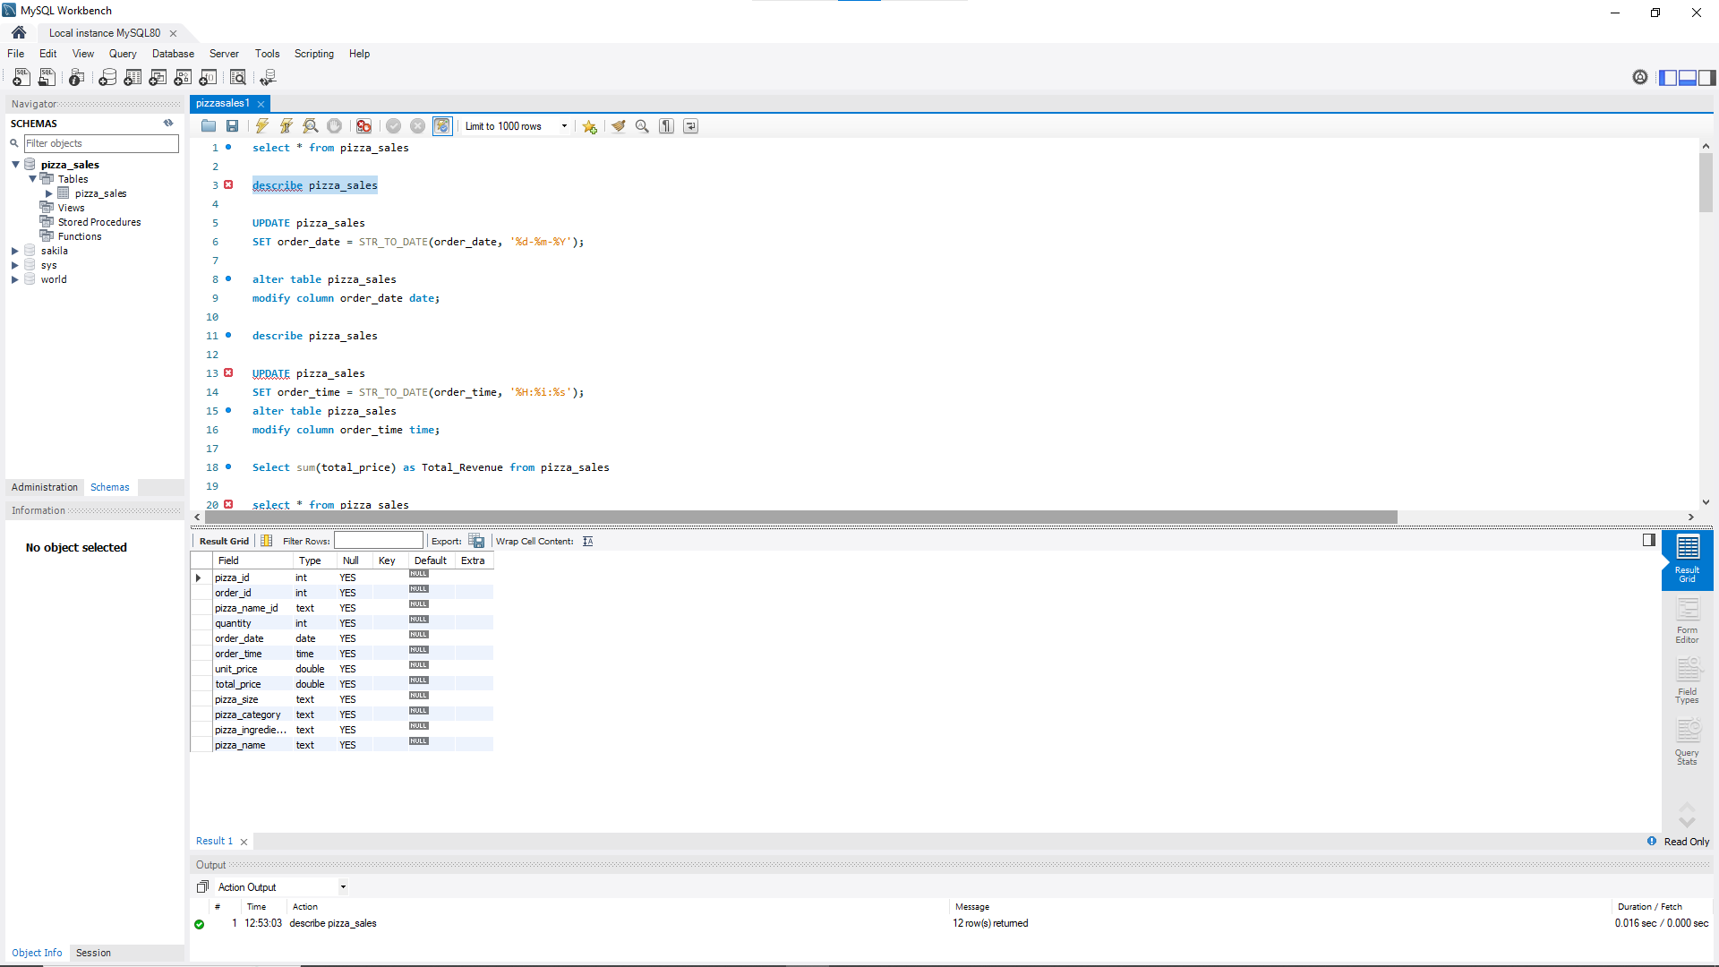

Order_date , order_time may have in text format or in mixed format. We have to check that and if needed we have to change those following data type to date and time. The query will be like this:

**UPDATE** pizza_sales

**SET** order_date = STR_TO_DATE(order_date, '%d-%m-%Y');

**alter** **table** pizza_sales

**modify** **column** order_date **date**;

**describe** pizza_sales

**UPDATE** pizza_sales

**SET** order_time = STR_TO_DATE(order_time, '%H:%i:%s');

**alter** **table** pizza_sales

**modify** **column** order_time **time**;

**Some additional queries**:

-- Create a new table with the same structure as pizza_sales

**CREATE** **TABLE** pizza_sales2 **LIKE** pizza_sales;

-- Check the new table (will be empty)

**SELECT** * **FROM** pizza_sales2;

-- Insert all data from the original table into the new one

**INSERT** **INTO** pizza_sales2

**SELECT** * **FROM** pizza_sales;

**KPI:**

**Exploratory Data Analysis (EDA):**

1. **Total Revenue:**

**Select** **sum**(total_price) **as** Total_Revenue **from** pizza_sales

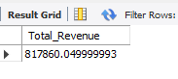

1. **Average Order Value:**

**SELECT** (**SUM**(total_price) / **COUNT**(**DISTINCT** order_id)) **AS** Avg_order_Value **FROM** pizza_sales

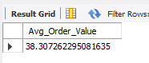

1. **Total Orders:**

**select** **count**(**distinct** order_id) **AS** Total_orders **from** pizza_sales

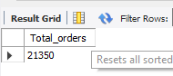

1. **Total Pizzas Sold:**

**select** **sum**(quantity) **AS** Total_Pizza_Sold **from** pizza_sales

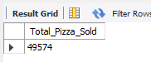

1. **Average Pizzas Per Order:**

**select** **cast**(**cast**(**sum**(quantity) **AS** **decimal**(10,2))/ **cast**(**count**(**distinct** order_id) **as** **decimal**(10,2)) **as** **decimal**(10,2)) **AS** Total_Pizza_Sold **from** pizza_sales

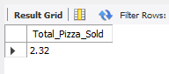

1. **Daily Trend for Total Orders:**

**/\***

**Select** DAYNAME(order_date) **as** order_day, **count**(**distinct** order_id) **as** total_orders **from** pizza_sales

**group** **by** DAYNAME(order_date)

**SELECT**

DAYNAME(order_date) **AS** order_day,

**COUNT**(**DISTINCT** order_id) **AS** total_orders

**FROM**

pizza_sales

**GROUP** **BY**

WEEKDAY(order_date), DAYNAME(order_date)

**ORDER** **BY**

WEEKDAY(order_date);

*/

**SELECT**

DAYNAME(order_date) **AS** order_day,

**COUNT**(**DISTINCT** order_id) **AS** total_orders

**FROM**

pizza_sales

**GROUP** **BY**

order_day, WEEKDAY(order_date)

**ORDER** **BY**

WEEKDAY(order_date);

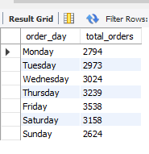

1. **Monthly Trend for Orders:**

**Unordered:**

**SELECT**

monthname(order_date) **AS** Month_name,

**COUNT**(**DISTINCT** order_id) **AS** total_orders

**FROM**

pizza_sales

**GROUP** **BY**

monthname(order_date)

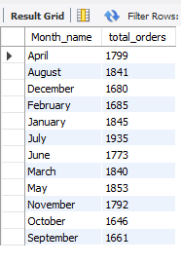

**Ordered:**

**SELECT** monthname(order_date) **AS** Month_Name, **COUNT**(**DISTINCT** order_id) **AS** Total_Orders

**FROM** pizza_sales

**GROUP** **BY** **MONTH**(order_date), monthname(order_date)

**ORDER** **BY** **MONTH**(order_date);

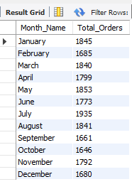

1. **% of Sales by Pizza Category:**

**SELECT** pizza_category, CAST(**SUM**(total_price) **AS** DECIMAL(10,2)) **as** total_revenue,

CAST(**SUM**(total_price) * 100 / (**SELECT** **SUM**(total_price) **from** pizza_sales) **AS** DECIMAL(10,2)) **AS** PCT

**FROM** pizza_sales

**GROUP** **BY** pizza_category

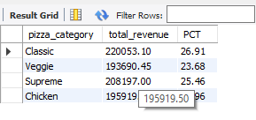

-- First month

**SELECT** pizza_category, CAST(**SUM**(total_price) **AS** DECIMAL(10,2)) **as** total_revenue,

CAST(**SUM**(total_price) * 100 / (**SELECT** **SUM**(total_price) **from** pizza_sales **where** month(order_date)=1) **AS** DECIMAL(10,2)) **AS** PCT

**FROM** pizza_sales

**where** month(order_date)=1

**GROUP** **BY** pizza_category

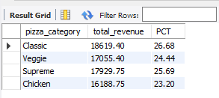

**9. of Sales by Pizza Size:**

-- % of Sales by Pizza Size

**SELECT** pizza_size, CAST(**SUM**(total_price) **AS** DECIMAL(10,2)) **as** total_revenue,

CAST(**SUM**(total_price) * 100 / (**SELECT** **SUM**(total_price) **from** pizza_sales) **AS** DECIMAL(10,2)) **AS** PCT

**FROM** pizza_sales

**GROUP** **BY** pizza_size

**Order** **by** PCT DESC

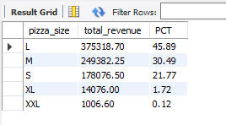

-- First quarter

**SELECT** pizza_size, CAST(**SUM**(total_price) **AS** DECIMAL(10,2)) **as** total_revenue,

CAST(**SUM**(total_price) * 100 / (**SELECT** **SUM**(total_price) **from** pizza_sales **where** quarter(order_date)=1) **AS** DECIMAL(10,2)) **AS** PCT

**FROM** pizza_sales

**where** quarter(order_date)=1

**GROUP** **BY** pizza_size

**Order** **by** PCT DESC

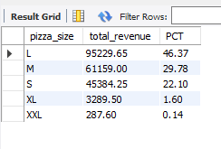

**10.Total Pizzas Sold by Pizza Category:**

**SELECT** pizza_category, **SUM**(quantity) **as** Total_Quantity_Sold

**FROM** pizza_sales

**WHERE** MONTH(order_date) = 2

**GROUP** **BY** pizza_category

**ORDER** **BY** Total_Quantity_Sold DESC

**Top 5 Pizzas by Revenue**

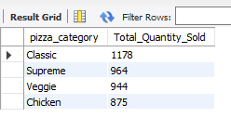

**11. Top 5 Pizzas by Revenue (Generic favouritism):**

**SELECT** pizza_name, **SUM**(total_price) **AS** Total_Revenue

**FROM** pizza_sales

**GROUP** **BY** pizza_name

**ORDER** **BY** Total_Revenue DESC

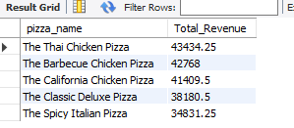

limit 5

**12. Bottom 5 Pizzas by Revenue:**

**SELECT** pizza_name, **SUM**(total_price) **AS** Total_Revenue

**FROM** pizza_sales

**GROUP** **BY** pizza_name

**ORDER** **BY** Total_Revenue asc

limit 5

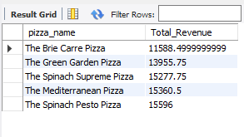

**13.Top 5 Pizzas by Total Orders(intensity indivdual favouritism indicator):**

**SELECT** pizza_name, **COUNT**(**DISTINCT** order_id) **AS** Total_Orders

**FROM** pizza_sales

**GROUP** **BY** pizza_name

**ORDER** **BY** Total_Orders DESC

limit 5

